Visual Basic Screenshots #9 - Arrays - Tom H

1. Integer Array = so one variable was holding one piece of information. An array is a variable that can hold more than one piece of information at a time. For example: Dim MyNumbers(4) As Integer. This will make 4 MyNumbers variables.
2. String Array = Like an integer array it allows you to print words one line after another through only setting one variable.
3. With arrays you set a value to each individual value in the array to display things like a times table and can be modified if a certain value is given to a text box.
4. 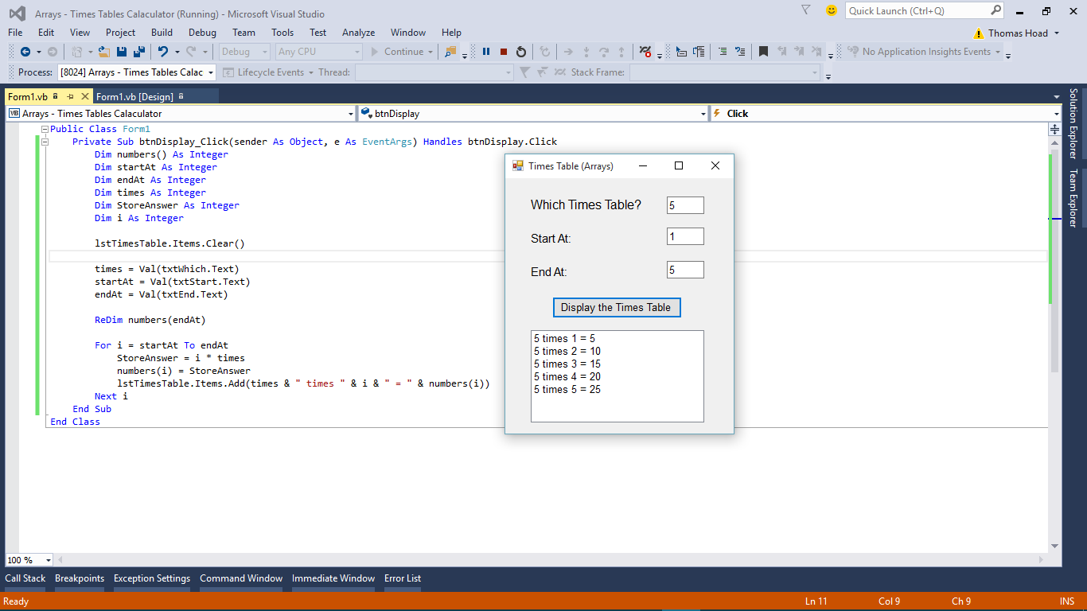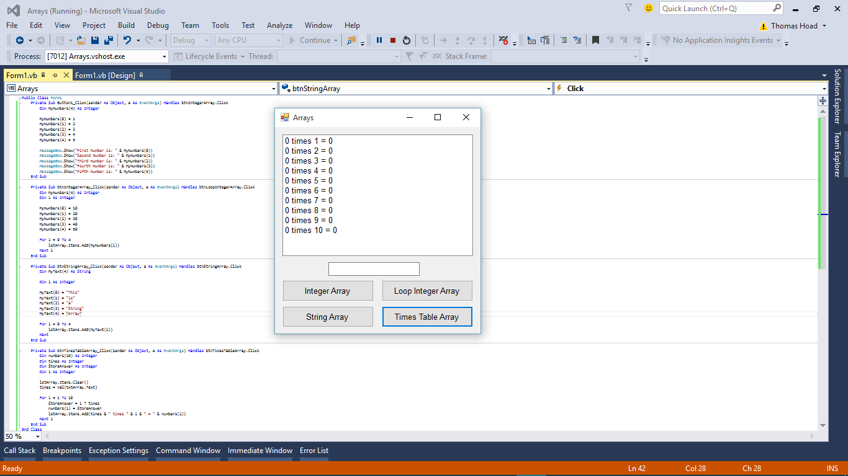‘ReDim’ can be used to reset the values of the array.